

Practices for Secure Software Report

Table of Contents
Document Revision History 3
Client 3
Instructions 3
Developer 4
1. Algorithm Cipher 4
2. Certificate Generation 4
3. Deploy Cipher 4
4. Secure Communications 4
5. Secondary Testing 4
6. Functional Testing 4
7. Summary 4
8. Industry Standard Best Practices 4

Document Revision History

Version | Date | Author | Comments
1.0 | Feb 17, 2026 | Jacob Ard | Generate Certificate
1.1 | Feb 18, 2026 | Jacob Ard | Run initial dependency-check
1.2 | Feb 20, 2026 | Jacob Ard | Add algorithm cipher Summary
1.3 | Feb 21, 2026 | Jacob Ard | Add screenshots of checksum & HTTPS
1.4 | Feb 21, 2026 | Jacob Ard | Add updated dependency-check
1.5 | Feb 21, 2026 |  | Write Summary
1.6 | Feb 22, 2026 | Jacob Ard | Write Best Practices

Client



Developer
Jacob Ard

Algorithm Cipher

Artemis Financial requires a secure hashing algorithm for file verification. Checksums, or digests, are a condensed representation of data that is generated by a hashing algorithm (NIST, 2017). This is a necessary security measure that is used to validate the authenticity and integrity of any piece of data or software by confirming that the checksum matches its expected value. For example, if a user downloads a piece of software, computes a checksum and finds that it is different from its expected value, then the software they’ve downloaded has been altered in some way – it may have been corrupted or compromised by an attacker. I recommend using the Secure Hashing Algorithm 2 with 256 bits, or SHA-256, which is a secure algorithm high collision resistance. Although SHA2 is also available with larger digest lengths of 384 and 512 bits, SHA-256 is an industry standard used by many applications.

SHA-256 is a secure hashing algorithm that is used to create hash digests needed to validate the integrity of data and software. Hash algorithms work by taking a piece of data and mapping it to a unique, fixed-length output (the hash value). SHA-256 has a high degree of collision resistance, which means that it is computationally unlikely for two different inputs to produce the same hash value (NIST, 2017). As part of the SHA-2 family of algorithms, SHA-256 has replaced older algorithms like MD5 and SHA-1, which are vulnerable to collisions (Umbelino, 2017). Attackers can exploit this vulnerability to deploy malicious code that matches the expected checksum. Currently, SHA-256 has no known collisions and there’s an extremely low probability that a collision will be discovered in the future. Furthermore, it is an industry standard that’s widely used for digital signatures, SSL certificates and cryptocurrency mining (‌Harish, 2024).

Certificate Generation
Screenshot of the CER file.

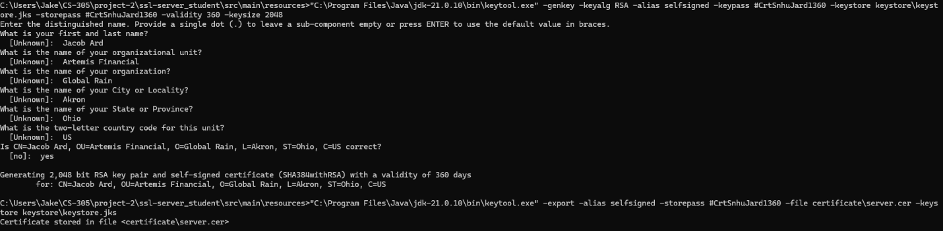

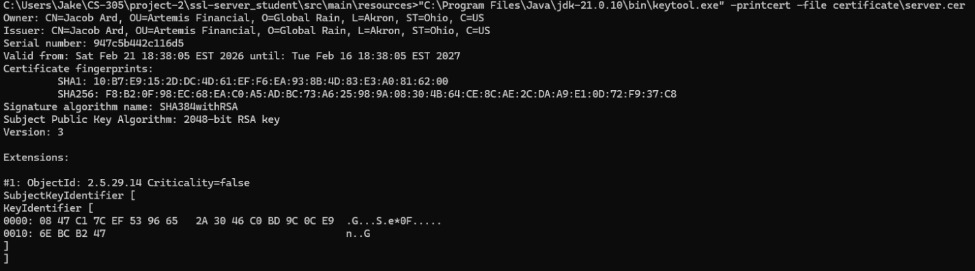
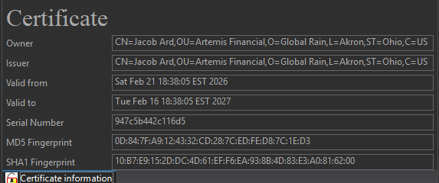

Deploy Cipher
Screenshot of the checksum verification.

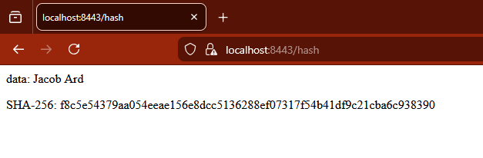

Secure Communications
Screenshot of the web browser that shows a secure webpage.

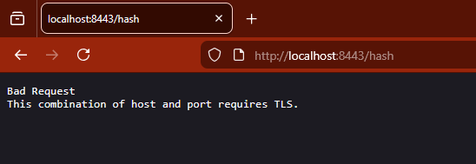
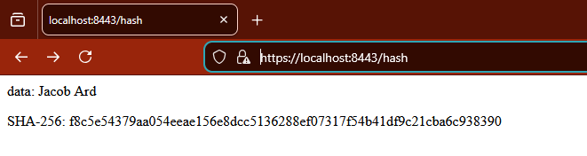

Secondary Testing
Screenshot below of the refactored code executed without errors and the dependency-check report.

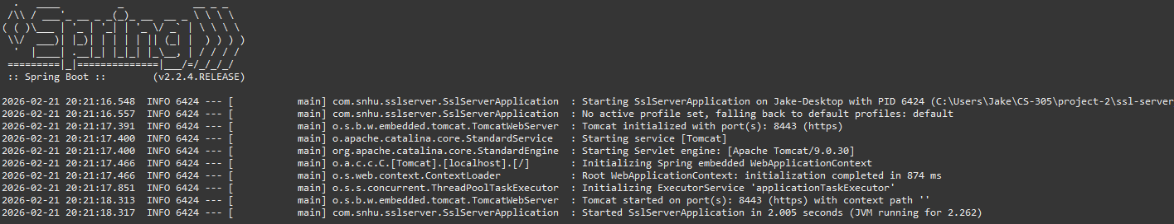

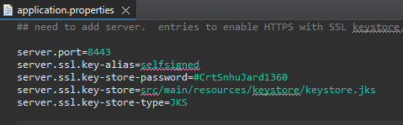
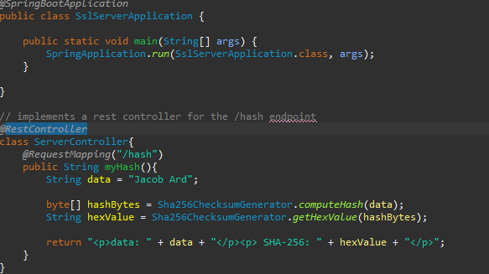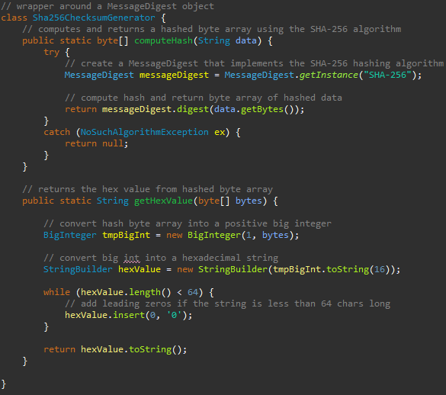
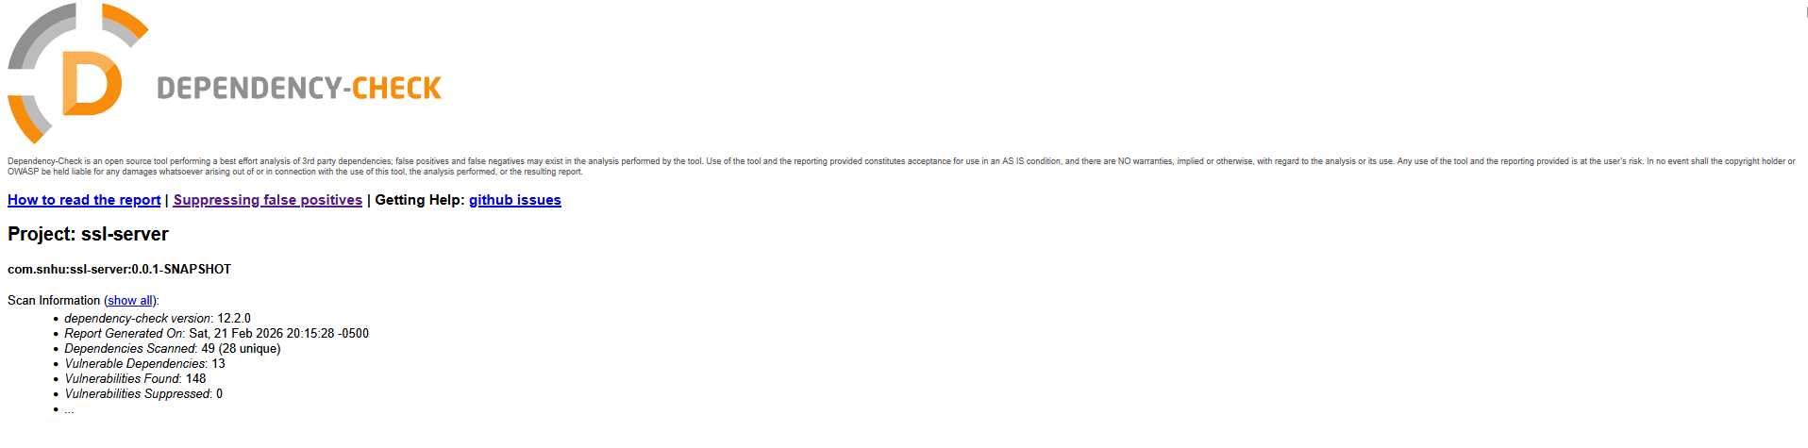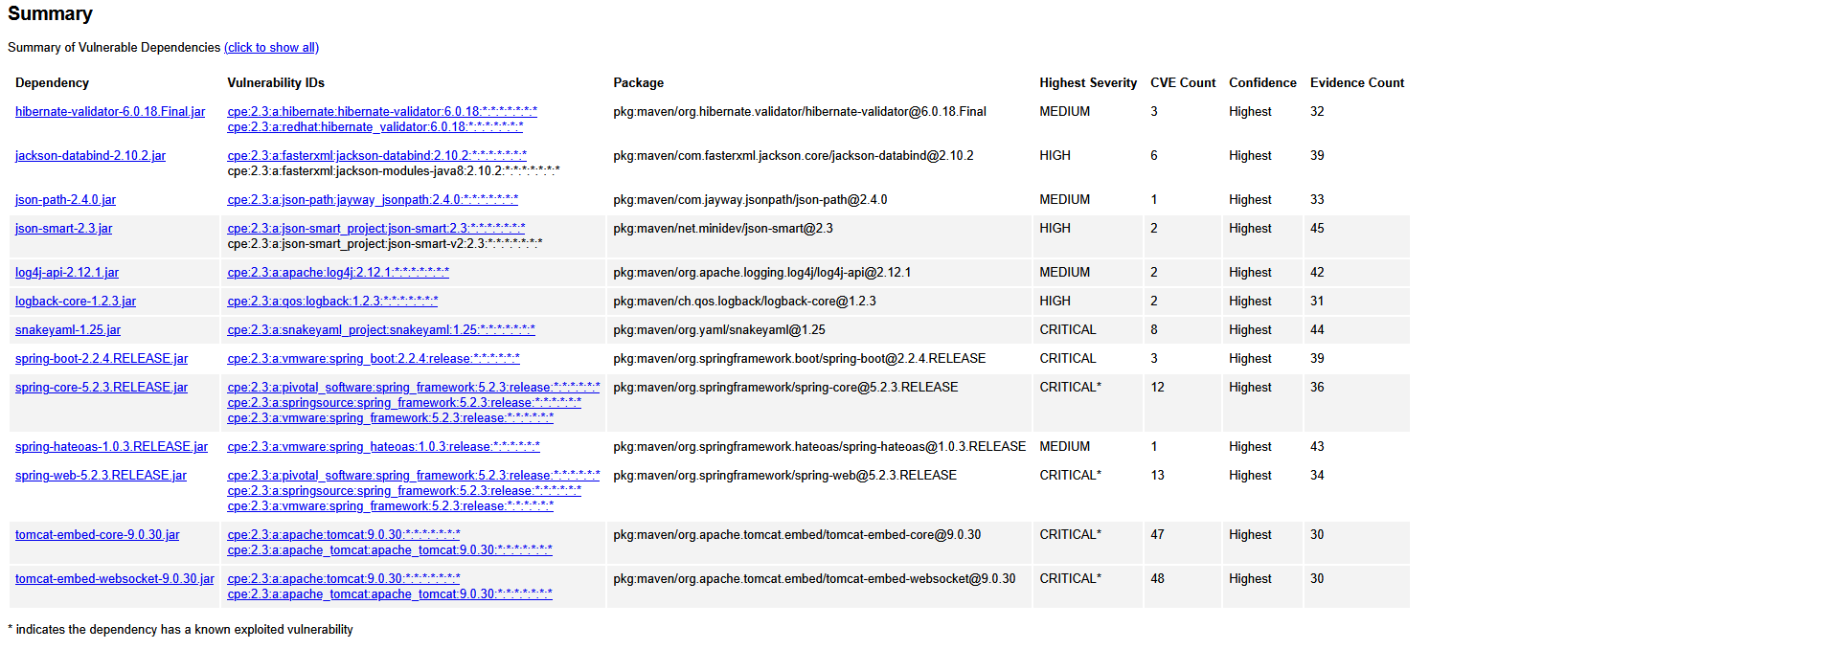
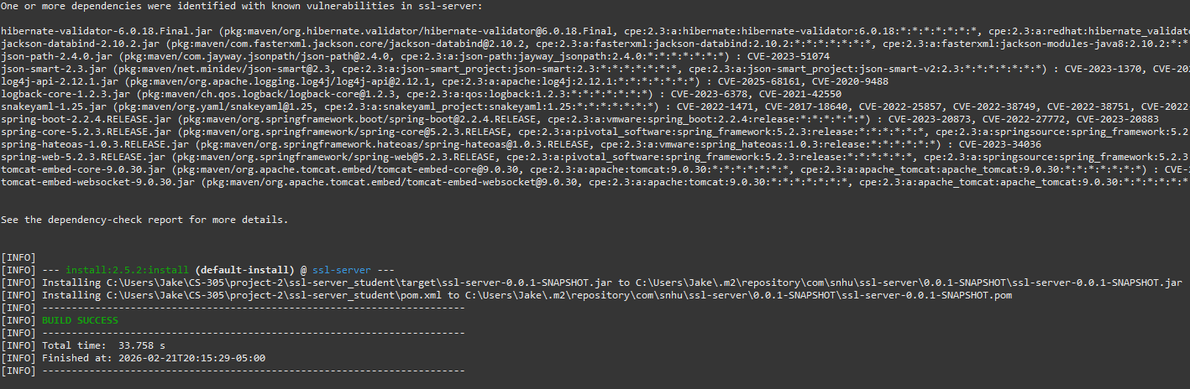

Functional Testing
Screenshot of refactored code executed without errors. Suppression xml and dependency-check results:
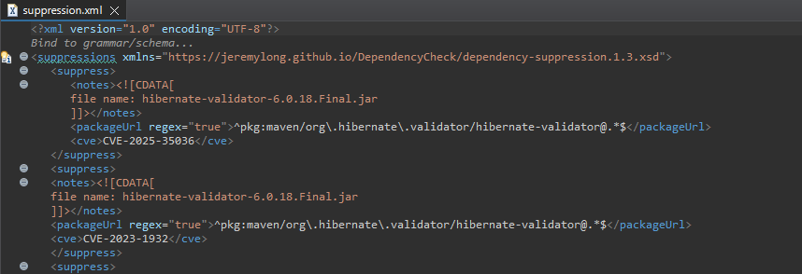
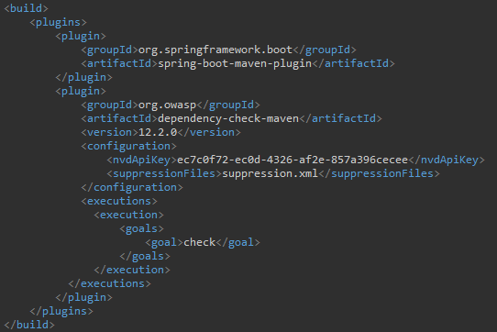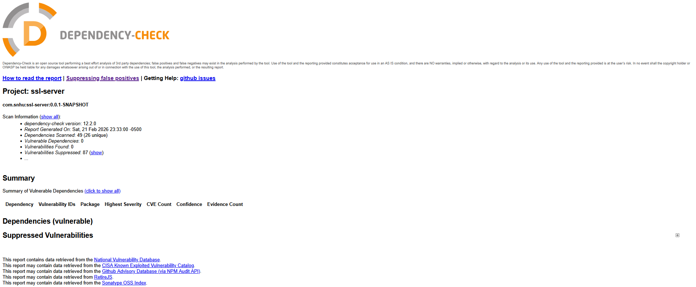

Summary

The changes I’ve made to the existing codebase provide a simple API endpoint demonstrating a SHA256 checksum and some additional refactor that improves the codebase in terms of secure API interactions, cryptography and code quality. The first step in the process was to generate a self-signed SSL certificate needed for secure communications via HTTPS. A self-signed certificate is necessary for testing the SSL server application in a development environment. However, it is worth noting that an SSL certificate ought to be obtained from a reputable certificate authority (CA) for production use. SSL/TLS certificates are a necessary cryptographic component of HTTPS used to authenticate a web server’s identity and encrypt communications between the client and server.

The next step was implementing Artemis Financial’s requirement for a cryptographic hash algorithm, which will ultimately be used to generate a checksum for file data verification. I implemented a simple controller endpoint (‘/hash’) which demonstrates the use of an industry standard, collision-resistant hash algorithm in the form of SHA-256. This endpoint shows that, when given a static input value, the SHA-256 algorithm will consistently generate a unique signature which can be used to validate the input. With a very low probability of collision, it is incredibly unlikely that two distinct SHA-256 inputs will result in the same output, making it an excellent choice for generating file checksums.

After generating the SSL certificate and implementing the hash controller, the next step was functional testing to verify that the application served the secure endpoint via HTTPS. Attempting to reach the endpoint via HTTP results in a standard error page that informs the client that HTTPS is required. Secondary testing involved configuring and running the OWASP Dependency Check to uncover vulnerabilities in the application code and its dependencies. The report uncovered critical vulnerabilities in multiple Spring and Tomcat packages. Although these were not patched, I added them to a suppression file to reduce noise and make it easier to detect other vulnerabilities within the codebase. Each CVE number is also documented in the suppression.xml file so that their respective packages may be upgraded when possible. After several iterations, the dependency check uncovered no further unknown vulnerabilities in the application.

Industry Standard Best Practices

In keeping with industry standard practices, I have adhered to modern protocols and secure cryptographic algorithms to deliver the required features for this project. I opted to generate an SSL key with an SHA-384 with RSA signature algorithm to support secure client-server communication. Likewise, I used the SHA-256 algorithm for checksum generation, as opposed to older algorithms like SHA1 or MD5, which are vulnerable to collision attacks. Using secure algorithms and implementing SSL/TLS for the application is in Artemis Finanical’s best interest because it reduces the risk of compromising sensitive data and strengthens organizational trust. For example, HTTPS is not only necessary for secure communication on the modern web, but the presence of a signed certificate validates the integrity of the application and allows the user to trust the identity of the websites they visit.

Reference
NIST. (2017, January 4). Hash Functions | CSRC. Nist.gov. https://csrc.nist.gov/projects/hash-functions
‌Harish, A. (2024, January 24). 2024 Complete Guide to SHA Encryption Types. SecureW2. https://www.securew2.com/blog/what-is-sha-encryption-sha-256-vs-sha-1
Umbelino, P. (2017, February 23). SHAttered — SHA-1 Is Broken In. Hackaday. https://hackaday.com/2017/02/23/shattered-sha-1-is-broken/
‌

